

**Tech shop project**

**Software Requirement Specification**

– Hanoi, August 2022 –

Record of changeS

|  |  |  |  |
| --- | --- | --- | --- |
| Date | A* M, D | In charge | Change Description |
| 14/Jan | A | TuLQ | Thêm introduction |
| 15/Jan | A | TrangTL | Thêm 3 phác họa 3 màn hình reset password, change password, view user list |
| 15/Jan | A | TuLQ | Thêm phác họa màn hình homepage (search và filter product),view product detail, view cart |
| 29/Jan | A | ThaiND | Thêm phác họa màn hình login và register |
|  |  |  |  |
|  |  |  |  |
|  |  |  |  |
|  |  |  |  |
|  |  |  |  |
|  |  |  |  |
|  |  |  |  |
|  |  |  |  |

*A - Added M - Modified D - Deleted

**Table of Contents**

1. Introduction 5

1.1 Purpose 5

1.2 Document Conventions 5

1.3 Project Scope 5

1.4 References 5

2. Overall Description 5

2.1 Product Perspective 5

2.2 User Classes and Their Use Cases 6

2.2.1 Visitor 6

2.2.2 Customer 6

2.2.3 Seller 6

2.2.4 Administrator 7

2.3 Operating Environment 7

2.4 Dependencies 7

Dependencies: 7

2.5 Business rules (Updating…) 7

3. Functional Requirements 7

3.1 System Functional Overview 7

**3.4** **View Product Detail** 13

**3.5** **Change Amount** 14

**3.6** **Delete Product** 15

**3.7** **Register** 16

4. Data Requirements 17

4.1 Logical Data Model (Updating…) 17

4.2 Data Dictionary (Updating…) 17

4.4 Data Integrity and Retention 17

5. External Interface Requirements 17

5.1 User Interfaces 17

The Clothing Shop Ordering System screen displays shall conform to the User Interface Design and User Experience Design 17

5.2 Software Interfaces (Updating…) 17

5.3 Hardware Interfaces 17

5.4 Communications Interfaces 17

6. Nonfunctional Requirements 18

6.1 Performance Requirements 18

6.2 Security 18

7. Other Requirements 18

Appendix A: Analysis models 19

Context Diagram 19

State Transition Diagram for Order 19

# 1. Introduction

This document describes the requirements for website, which provides tech deviced for purchaser. Types of reader this document is intended for: developers, project managers, testers, customers, etc…

Visitor

Customer

Seller

Marketer

Admin

# 2. Overall Description

## 2.1 Product Perspective

Online Shopping System is a kind of online shop where a seller can sell his/her products or services and customers can buy. Selling online has been easier, faster, or more convenient than with traditional selling.. We have developed this mini project Online Shopping System on Java, JSP, and SQL. In case something bad happens, including system failure or negative feedback,… the administrator will be able to maintain and modify the site. This system supports the below types of user…

## 2.2 User Classes and Their Use Cases

## 2.2.1 Visitor

A visitor is someone who visit the website to learn more information about clothes sold on this website. Use cases:

1: View all products

2: Search for a product

3: View product’s detail

4: Read blog

## 2.2.2 Customer

A customer is someone who orders a product from the website. Use cases:

1: Login

2: View all products

3: Search for a product

4: View product’s detail

5: Add product to cart

6: Checkout

7: Check order status

8: Cancel order

9: Rate product

10: Give feedback

11: Read blog

## 2.2.3 Seller

A seller is someone who has the responsibilities to manage the website’s products and the business important data

1: Create a product

2: Modify a product

3: Delete a product

4: Add promotion detail

5: View dashboard

## 2.2.4 Marketing

1: View MKT dashboard

2: View blogs list

3: Edit blog

4: Delete blog

## 2.2.5 Administrator

An administrator is the person who has the responsibility to manage users of website. Use cases:

1: Change users’ information

2: Delete an user

## 2.3 Operating Environment

The website will be compatible with standard web browsers on Computer and Smart Phone platforms.

## 2.4 Dependencies

## Dependencies:

* User’s environment (Browser)
* User’s devices (Computer, Smart phone,…)
* External libraries

## 2.4 Business rules

# 3. Functional Requirements

## 3.1 System Functional Overview

#### Screen Flow

User

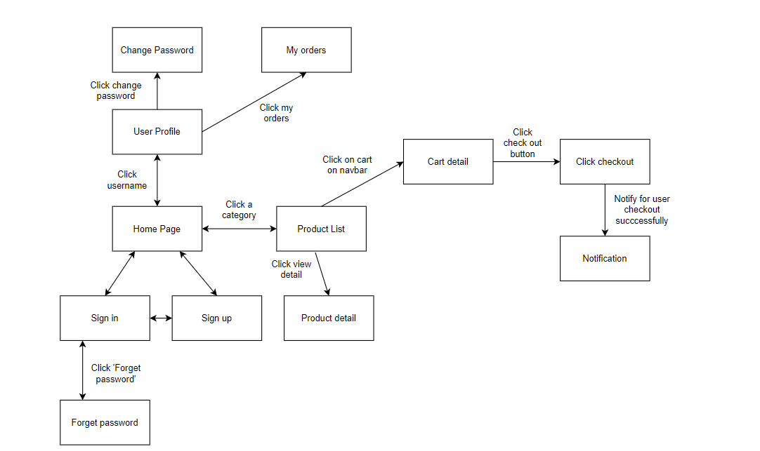

Figure 1-1: Screen Flow for User

Admin

Figure 1-2: Screen Flow for Admin

Marketing

Figure 1-3: Screen Flow for Marketing

Seller

## 

Figure 1-4: Screen Flow for Seller

#### Screen Details

|  |  |  |  |
| --- | --- | --- | --- |
| **#** | **Feature** | **Screen** | **Description** |
|  | Search & Filter Product | Home Page | Search for a Product by name or filter it by category |
|  | View product list | Product list | View all product by category |
|  | View Product Detail | Product Details | Display detail information of Product |
|  | Change Amount | Cart Details | Plus or Minus the Amount of a Product in Cart |
|  | Delete Product | Cart Details | Delete a Product in Cart |
|  | Delete Cart | Cart Details | Delete all the Product in Cart |
|  | Login | User Login | User Login to the System |
|  | Register | User Register | User Register for an account |
|  | View User List | Users List [Admin] | Admin View the list of all Accounts in the System |
|  | Edit User | Users List [Admin] | Admin Edit information of an Account |
|  | Delete User | Users List [Admin] | Admin Delete an Account from the System |
|  | Add Ship Information | Cart Completion | User enter all shipping information for delivery |
|  | Change Ship Information | Cart Completion | User can change the existing shipping information for delivery |
|  | Reset Password | Reset Password | When user forget password, send a verification code through Email for user to reset password |
|  | Change Password | Change Password | Change user’s old password with new password |
|  | User Profile | User Profile | User views information about his account |
|  | My Orders | My Orders | User views the history of all orders he made |
|  | Order Information | Order Information | User views detail history of a specific order |
|  | View Product List | Products List [Sale] | Seller views all of Products that he sells |
|  | Sale Dashboard | Sale Dashboard [Sale] | Seller views Statistic of the sale of his products |
|  | Orders List | Orders List [Admin] | Admin views list of all of 2orders |
|  | Order Details | Order Details [Sale] | Seller views the detail of 1 of his orders |

|  |  |  |  |
| --- | --- | --- | --- |
|  | View Feedback | Feedback | Customer views all the Feedbacks about a Product |
|  | Send Feedback | Feedback | Customer writes and send a Feedback about a Product |
|  | Blogs List | Blogs List | Customer views the list of all Blogs |
|  | Blog Details | Blog Details | Customer views the Detail information of 1 Blog |
|  | View Notification | Notification | User views the list of new Notifications |
|  | View all Notification | Notification | User views the list of all Notifications |
|  | Mark as Read | Notification | User mark all the new Notification as read |
|  | Error | Error | Show in case there’s an Error occurs |

#### c. Screen Authorization

| **Screen** | **Guest** | **User** | **Seller** | **Admin** |
| --- | --- | --- | --- | --- |
| Home Page | x | x |  |  |
| Product Details | x | x |  |  |
| Cart Details |  | x |  |  |
| User Login | x |  |  |  |
| User Register | x |  |  |  |
| User Authorization | x |  |  |  |
| Users List [Admin] |  |  |  | x |
| Cart Completion |  | x | x | x |
| Reset Password |  | x | x | x |
| Change Password |  | x | x | x |
| User Profile |  | x | x | x |
| My Orders |  | x |  |  |
| Order Information |  | x |  |  |
| Products List [Admin] |  |  |  | x |
| Sale Dashboard [Sale] |  |  | x |  |
| Orders List [Sale] |  |  | x |  |
| Order Details [Sale] |  |  | x |  |
| Feedback | x | x |  |  |
| Blogs List | x | x |  |  |
| Blog Details | x | x |  |  |
| Notification |  | x | x | x |
| Error | x | x | x | x |

In which:

* Guest: Customer who has not yet logged in to the site
* User: Customer who has an account an has logged in
* Seller: People who sell products in the shop
* Admin: People who manage the shop

**3.2 Search & Filter Product**

* Function trigger: User accesses the website
* Function description:
  + Role: Guest, User
  + Purpose: Users Search for the Product they want

Screen layout:

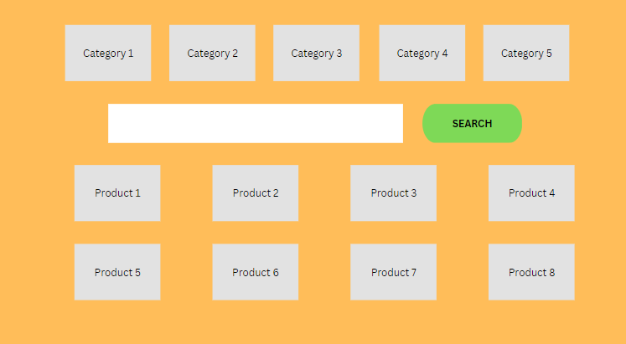

**3.3: View product detail**

* Function trigger: User Click on a Product in Home Page
* Function description:
  + Role: Guest, User
  + Purpose: User can view all the detail information of a Product

Screen layout:

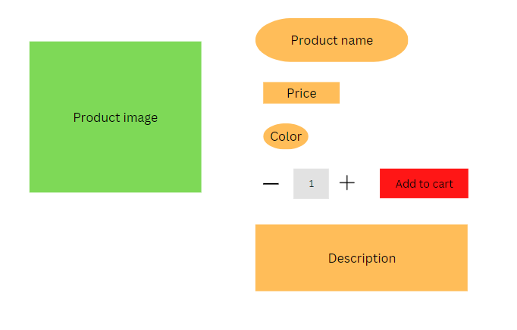

* 1. **:** **Delete Cart**
* Function trigger: User Click on the Delete cart icon in Cart
* Function description:
  + Role: Guest, User
  + Purpose: User can delete all the Product in their Cart

Screen layout:

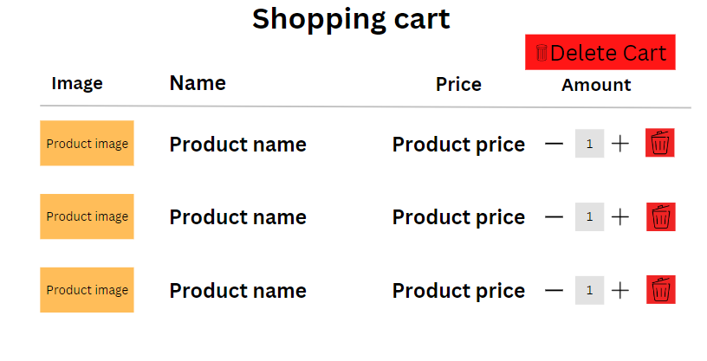

**3.5:Reset Password**

* Functional trigger: Users access the website and click on “Reset Password” button
* Functional description:
  + Role: Customer, Seller, Admin
  + Purpose: User can retrieve password when forgotten by confirming information via email
* Screen layout:

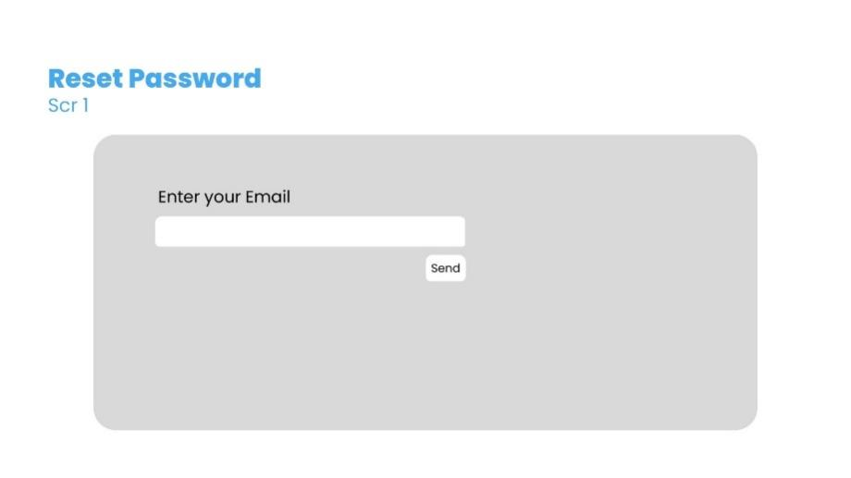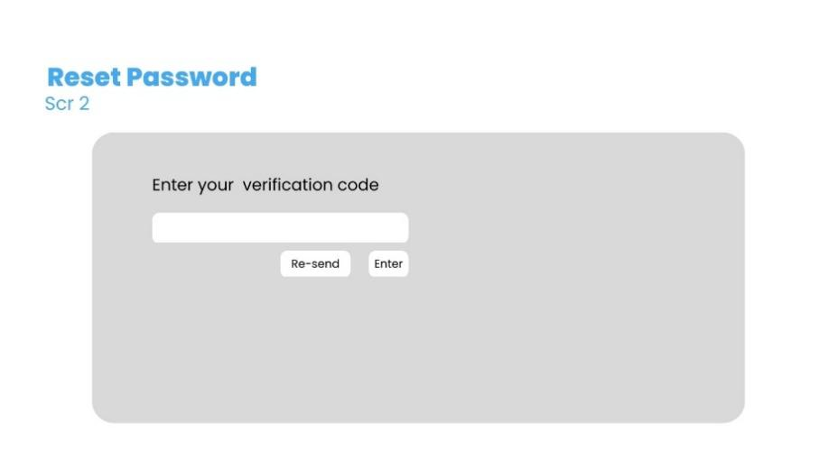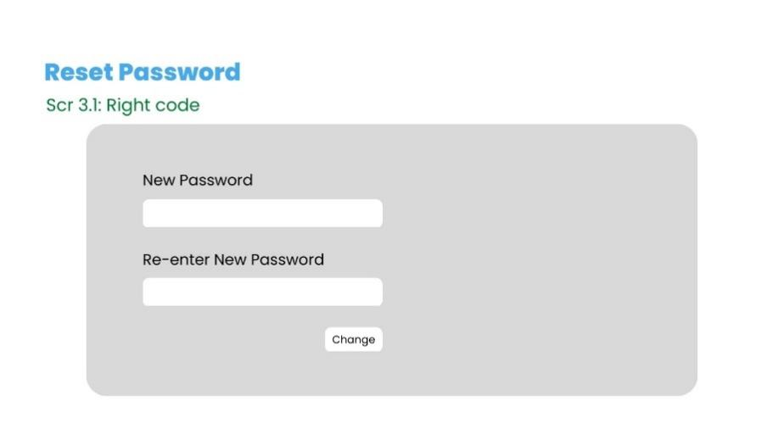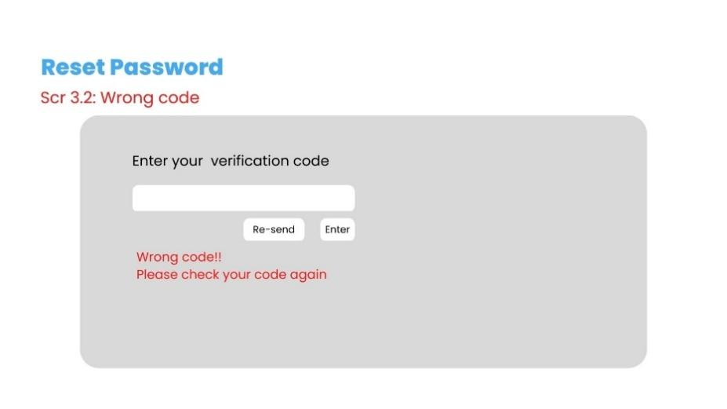

**3.6:Change Password**

* Functional trigger: Users access the website and access the profile page and click on “Change Password” button
* Functional description:
  + Role: Customer, Seller, Admin
  + Purpose: User can change their password
* Screen layout:

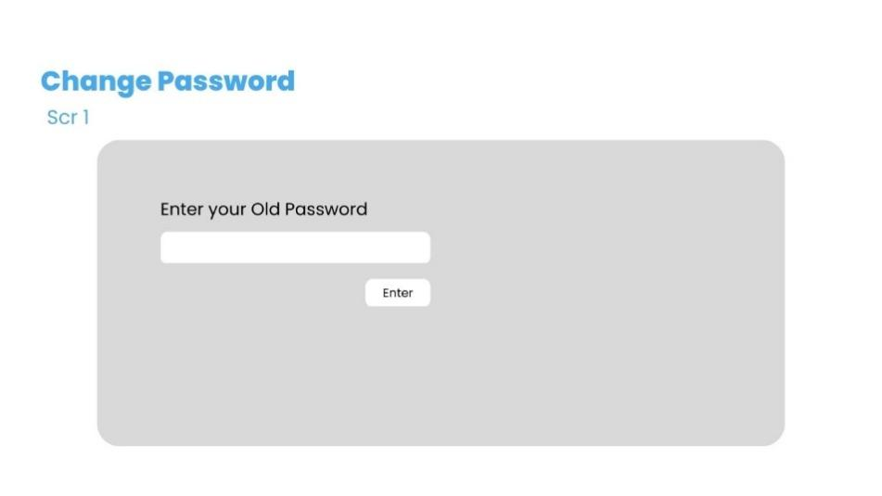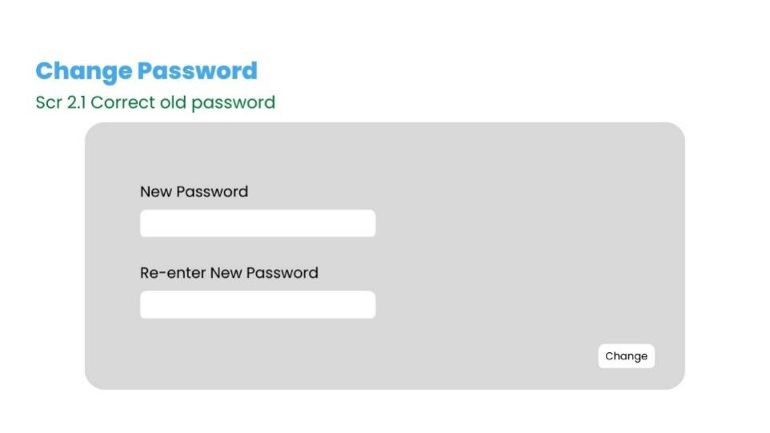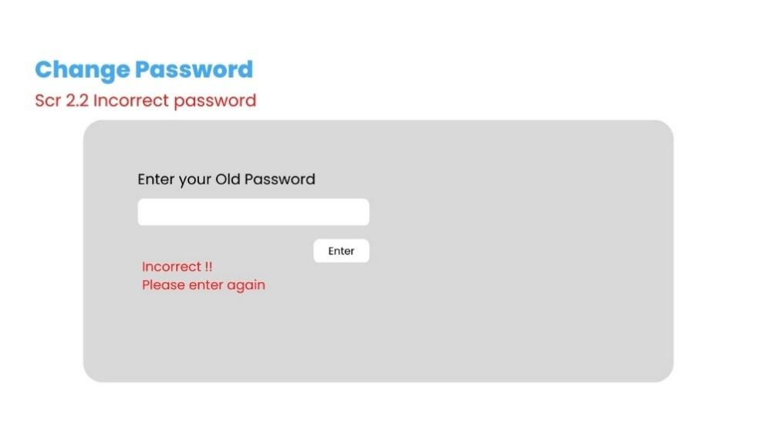

**3.7:View User List**

* Functional trigger: Admin click on “Manager Account” from Admin Dasboard
* Functional description:
  + Role: Admin
  + Purpose: View list of all account
* Screen layout:

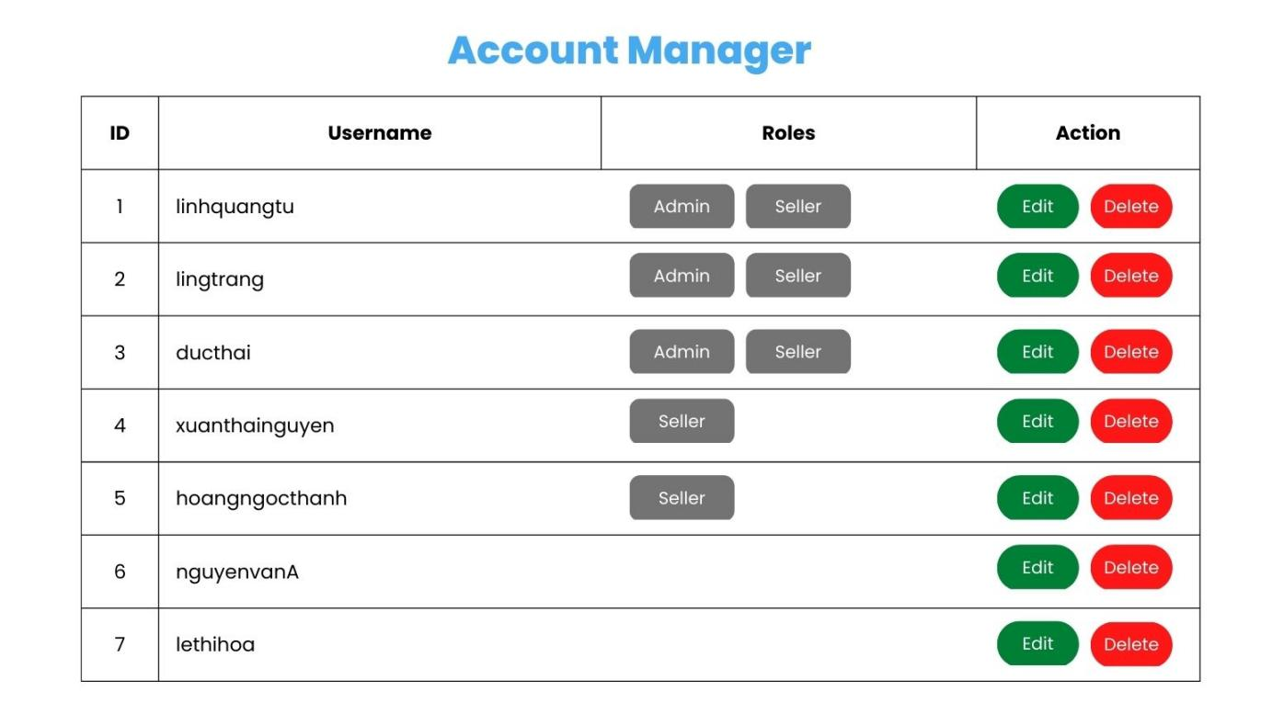

**3.8. Login**

* Functional trigger: User input username and password to login an account
* Functional description:
  + Role: Public
  + Purpose: User login an account to view,buy product,view blog ,…
* Screen layout:

**3.9.Register**

* Functional trigger: If user does not have an account , User can input username and password , confirmation password , email , phone , gender to register an account
* Functional description:
  + Role: Customer
  + Purpose:
* Screen layout:

**3.10:View Blogs List**

* Functional trigger: User access website can view the blogs list
* Functional description:
  + Role: User
  + Purpose: View list of all blogs
* Screen layout:
* 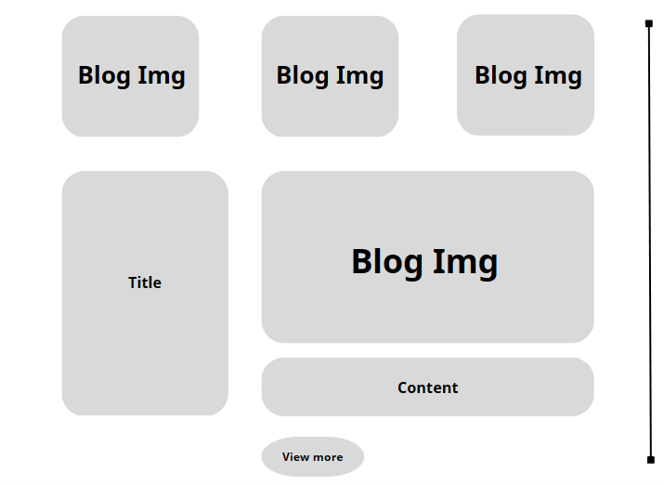

**3.11:View Blogs Detail**

* Functional trigger: User click on “Blog img” or button “View more” under each blog
* Functional description:
  + Role: User
  + Purpose: View blog details
* Screen layout:

